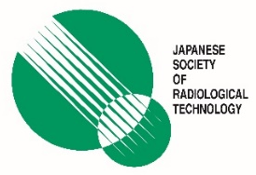
The 76th Annual Meeting of the Japanese Society of Radiological Technology
April 9-12, 2020, Yokohama, Japan

International Scholarship Application From
Note
- Please fill in the colored cell and tick ☒ a box.
- Please be reminded to submit an abstract through the website on or before October 28, 2019.
- Scholarship recipients must be the first author of an accepted abstract for oral presentation.
- The completed application form should be sent to jsrt76-int@jsrt.or.jp no later than October 31, 2019.
- Notifications of acceptance or rejection will be sent via email by December 2019.
- If you receive the award this year, you won’t be able to apply to any other JSRT scholarship in future.

Applicant Information
Are you willing to receive the JSRT International Scholarship 2020? | ☐Yes ☐No

Full Name  (in Alphabet) | First | Last | Middle
Date of Birth | Year | Month | Day
E-mail Address

Gender | ☐ Male ☐ Female
Age

Nationality or Citizenship
Your current residential country
Affiliation (Name of your employer, hospital, university)
Current profession/ occupation/ position

Have you ever received any JSRT scholarship before? | ☐ Yes ☐ No
About your abstract
Abstract Title
Submission Number |  | IRB Approval | ☐ Yes ☐ No

