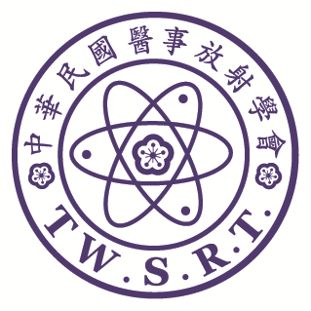

The 59th Annual Meeting of TWSRT and
the International Conference of Medical Imaging

Deadline: 2026/1/12
Submission Form
Name:
Institute: Department: E-mail:
Phone: Ext: Fax:
Address:□□□

Presentation Option:
□ Oral Speaker： □ E-Poster
Notes:
- Abstract text: limited to 300 words.
- When you complete abstract, please delete the yellow-marked texts about the format’s regulation, such as (Times New Roman, 11 Points, Bold type) and (Please list 3-5 keywords), etc.

- If the submitting author isn’t same as corresponding author, please mark corresponding author by “*”.
Title (Times New Roman, 12 Points, Bold, Centered)
Name¹ XXX² (Times New Roman, 11 Points, Bold, Centered)
¹Authors Affiliation (Hospital and Department) ²XXX(Times New Roman, 11 Points, Bold, Centered)
(If the authors belong to the same department, the numbers are waived)
Examples: Ying-Ling Chen ¹ Jyun-Ru Chen²
¹ Department of Radiology, Cathay General Hospital ² Department of Radiology, MacKay Memorial Hospital

Purpose (Times New Roman, 11 Points, Bold type)
…………………………………………………..………………………..…………………………………………………………………………(Times New Roman, 11 Points, Single space)

Materials and Methods (Times New Roman, 11 Points, Bold type)
…………………………………………………..………………………..…………………………………………………………………………(Times New Roman, 11 Points, Single space)

Results (Times New Roman, 11 Points, Bold type)
…………………………………………………..………………………..…………………………………………………………………………(Times New Roman, 11 Points, Single space)

Conclusion (Times New Roman, 11 Points, Bold type)
………………………………………………………………… (Times New Roman, 11 Points, Single space).
Keywords: Please list 3-5 keywords (Times New Roman, 11 Points, Bold type)
…………………………………………………………………(Times New Roman, 11 Points, Single space)

If you have any questions, please feel free to contact us by email at:service@twsrt.org.tw

Official Website
(Annual Conference Page)

